OFFICIAL LEAGUE ROSTER - BASKETBALL
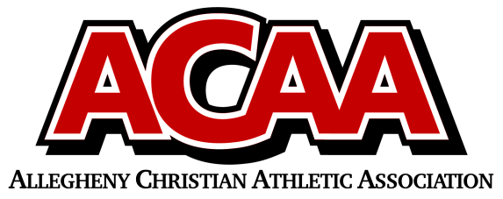

School Name: Great Commission School
Team Colors: Royal Blue & White
Overall Wins ___ Losses ____ Ties ___
ACAA Wins ___ Losses ____ Ties ___ OPPONENT: __________________________
DATE: _________
Number | Name | Year | Position | Height | Homeschool
10 | Michelle McConnell | 12 |  | 5’5
21 | Kayelynn Summers | 12 |  | 5’
33 | Rachel Turiano | 12 |  | 5’9
25 | Sophia Fleck | 11 |  | 5’6
15 | Bayla Miller | 11 |  | 5’8 | YES
11 | Alexa Hall | 10 |  | 5’1
2 | Trinity McConnell | 10 |  | 5’5
14 | Nadia Wertz | 9 |  | 5’3
3 | Sara Stachmus | 9
0 | Ava Bordack | 8
23 | Adalee Bickings | 8

Head Coach: KAY BORDACK
Asst. coach: Chuck Lohsl, Beth Campbell

AD: JULIE LOHSL

Official ACAA League Team Roster. to be submitted to the scorer’s table before each game.

